**Hero’s Quest**

Design Document

By: Aleck Bowen Sun

**Description:**

After 5 years of training, you are finally ready to become a master swordsman. The sensei is waiting at the peak of the dangerous Mt. Everisk to honour you with this title. After several weeks of gruesome climbing, the peak is just within your reach. Suddenly, a pack of vicious Yetis begin hurling snowballs towards you! It is up to you to defend against these snowballs! This is your final test to become a master swordsman! Each snowball you block will increase your score! Survive the attack, conquer Mt. Everisk, and reach for the highest score possible to become a master swordsman!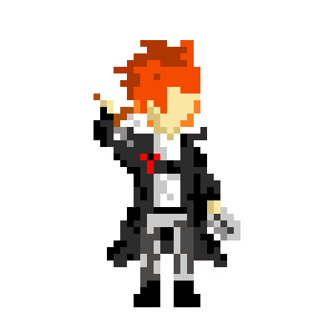

**Difficulty:**

The game has three difficulty levels: easy, medium, and hard. The difficulty affects how fast and how many snowballs fly at you.

* Easy: slow snowballs, few snowballs on screen
* Medium: fast snowballs, few snowballs on screen
* Fast: super fast snowballs, significantly more snowballs

However, do not worry! Playing at a more difficult level increases your score multiplier! This way, pro players can reach for higher scores in a more efficient way! At easy, each snowball block is 1 point, medium is 2 points, and hard is a whopping 5 points!

**Instructions:**

To begin, right click the python file “Hero’s Quest” and select edit with idle. Then press F5 to begin the game.

The game will first show a splash screen in order to give credit to the amazing creator who made this game possible. After 1 second, the actual game will launch. It will enter a storyline where you can continue reading through the story and instructions by pressing space.

Once the story is completed, it will bring you to the title page where you will select play using your mouse. The difficulty page will then open allowing you to select easy, med, or hard with your mouse. Med stands for medium difficulty. The game will then begin when a difficulty level is selected. Snowballs will be coming in from different paths. Use the right, down, and left arrow keys to block snowballs coming from the corresponding direction. Press the arrow keys when the snowballs are inside the range of your sword, which is represented by the dark grey box on the path. Time it too early and you will miss! Time it too late and you will be hit by the snowball and lose a life. If you lose all your lives, the game will be over. Each snowball blocked will increase your score.

Once you have lost all your lives, the final score will be displayed on the screen. Then click the home button with the mouse to return to the title screen where you can play again. Reach for the highest score possible and become a master swordsman!

**Design Visualization:**

